Practical - 2
Practical Title: Semantic HTML5 Pages with Accessibility-Ready Structure
Problem Definition 1: Develop static HTML5 skeletons for at least 10 Student Hub pages such as: Home, About, Register, Login, Dashboard, Events, Profile, Contact, Admin, FAQ, and Feedback. Use semantic tags and accessibility-friendly structure.
Theory
1: Are semantic tags such as header, nav, main, section, article, aside, and
footer used properly?
Answer: Yes.

2: Are form labels, headings, image alt text, and navigation links
accessible?
Answer: Yes.

3. Is the page structure consistent across all pages?

Answer: Yes because I used auto margin option.

Implementation/ Output/Result (Keep only one option which is suitable to practical)
HTML Tags Summary
Across all provided files, the following HTML tags are used:
- Document Structure: <!DOCTYPE html>, <html>, <head>, <title>, <meta>, <body>
- Text & Layout Content:<h1>, <h2>, <h3>, <p>, <hr>, <br>
- Links & Media: <a>, <ul>,<li>
- Tables: <table>, <tr>, <th>, <td>
- Forms & Interactive Elements: <form>, <label>, <input> (text, password, date, file, submit, radio, reset), <select>, <option>, <textarea>, <button>

- Evidence of Work (Screenshots): HTML SCREENSHOTS:

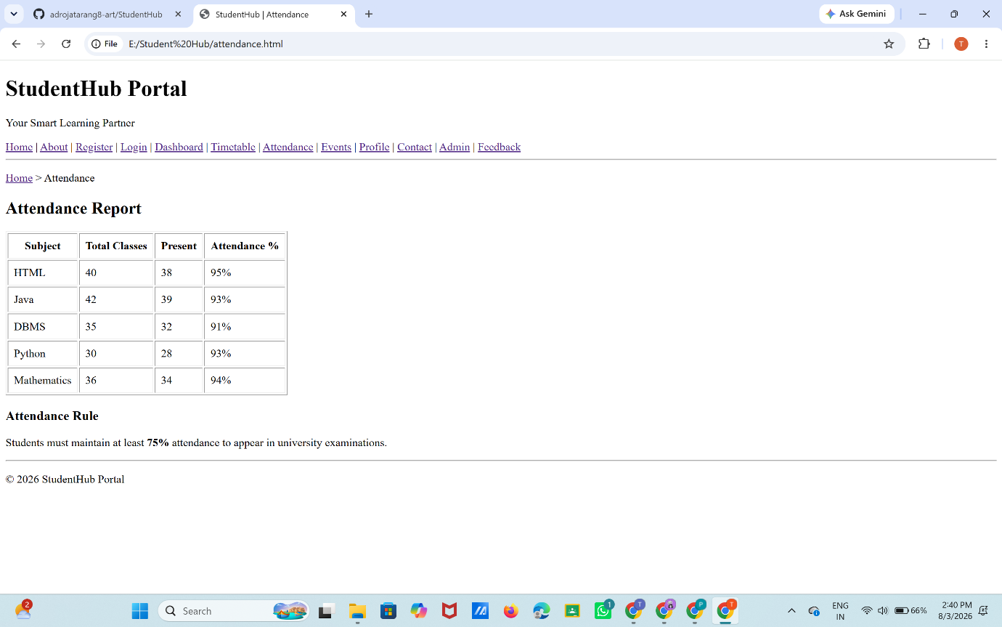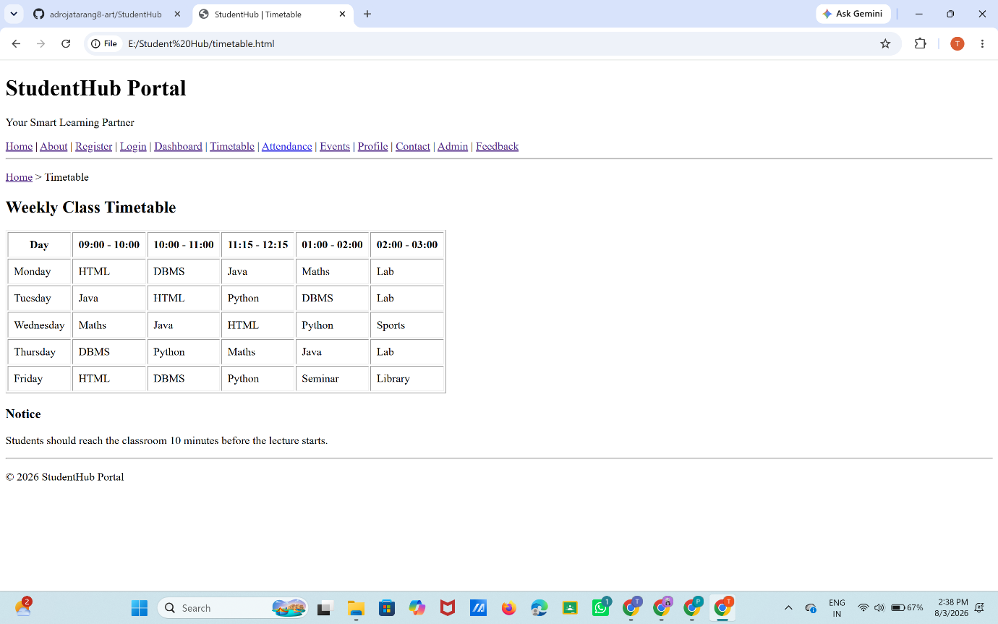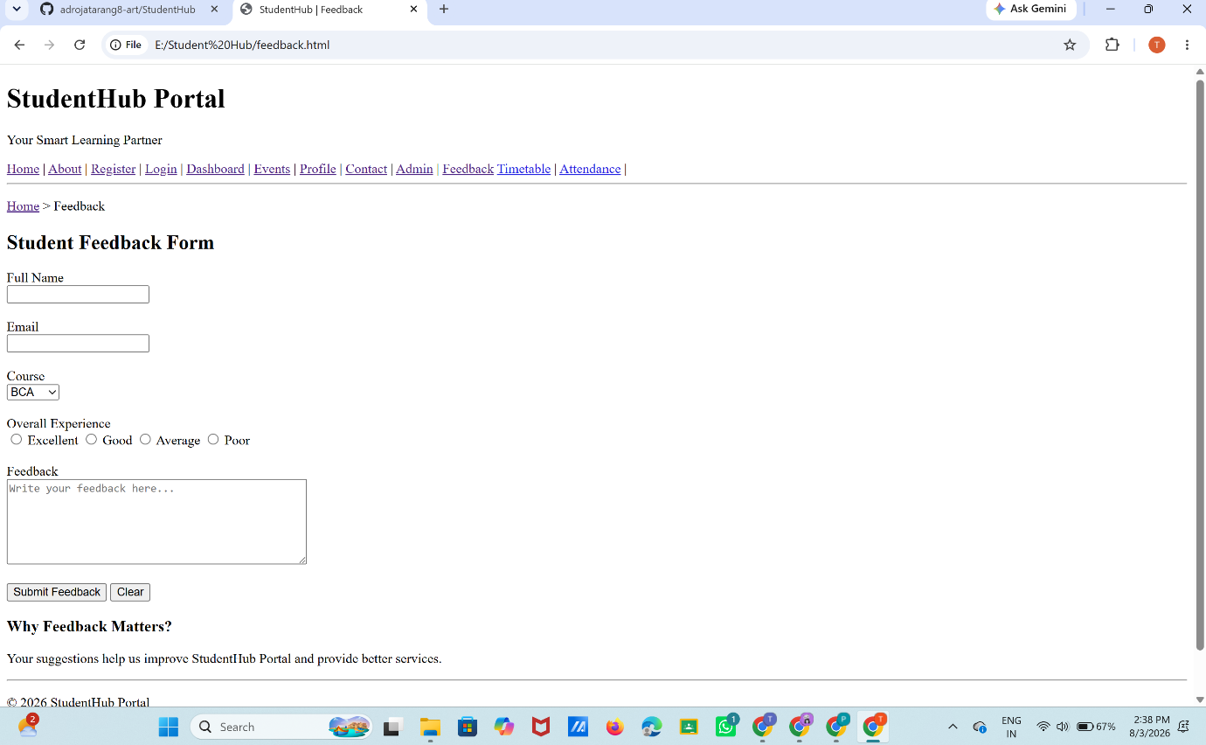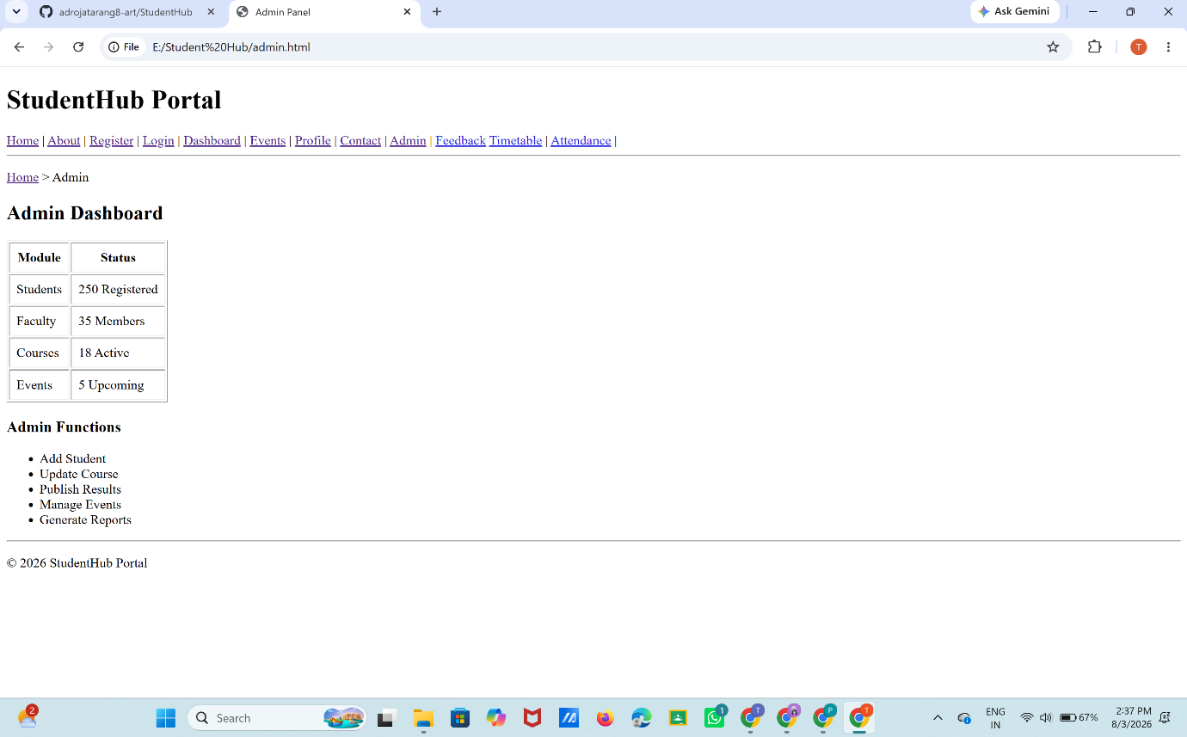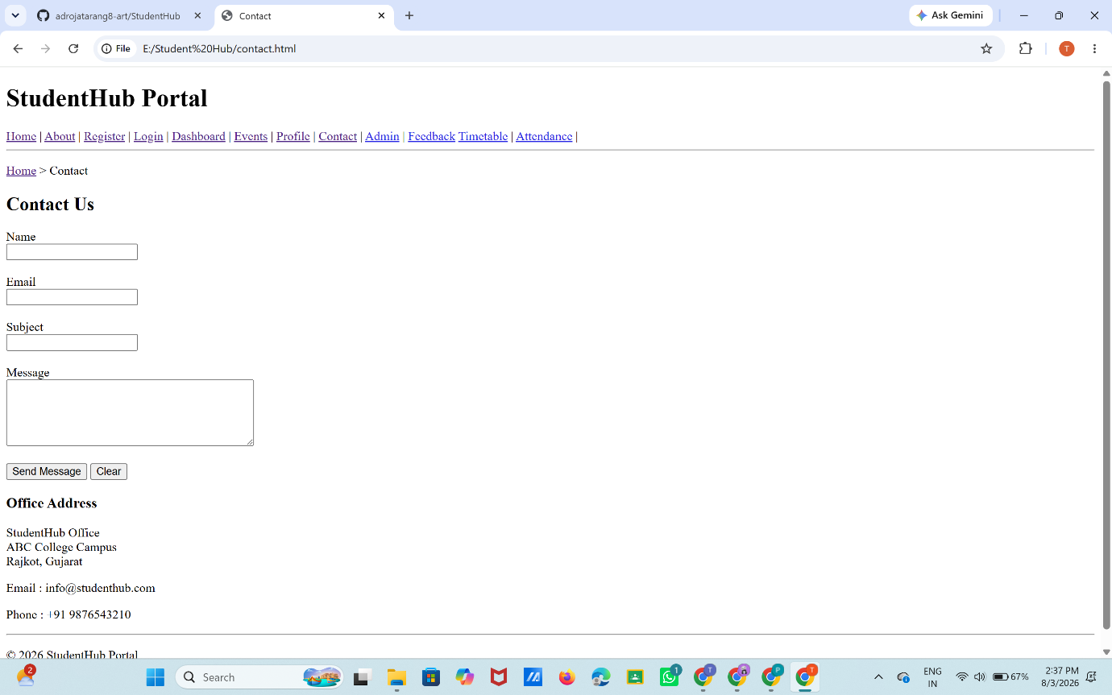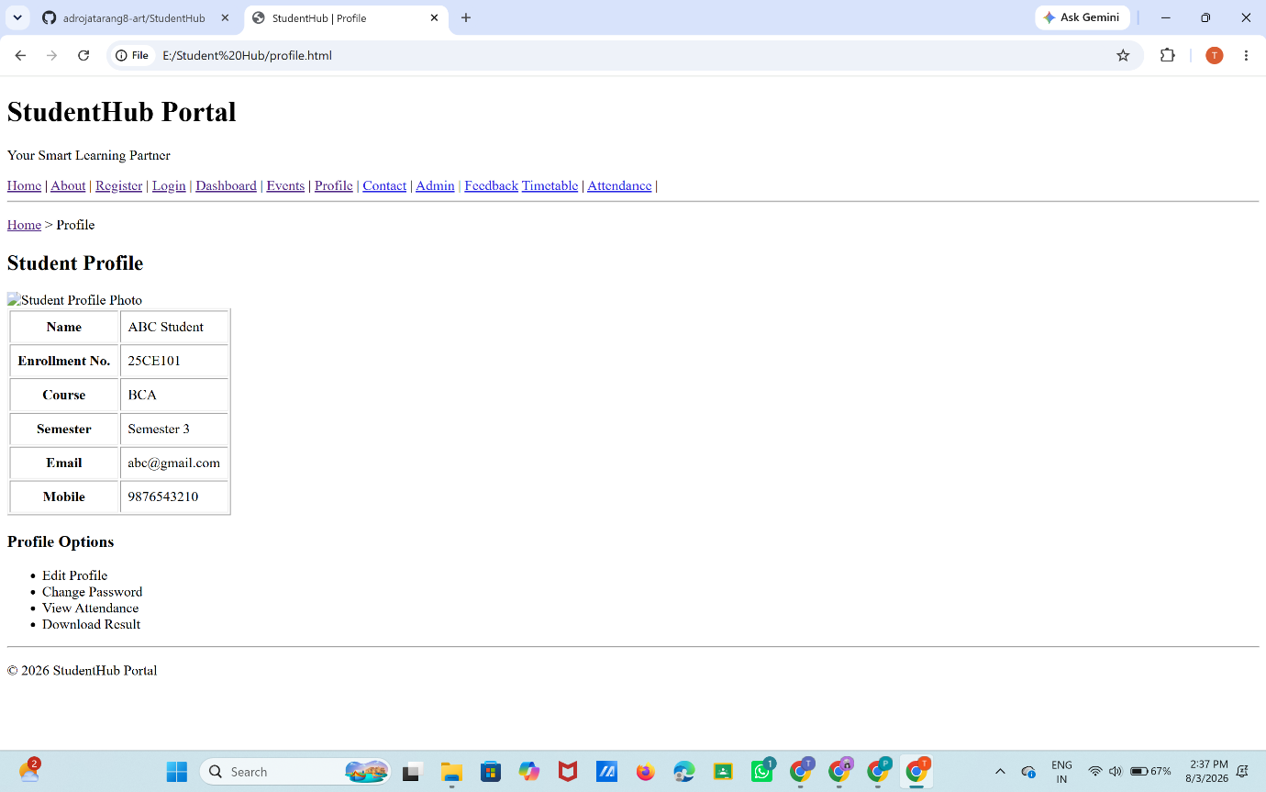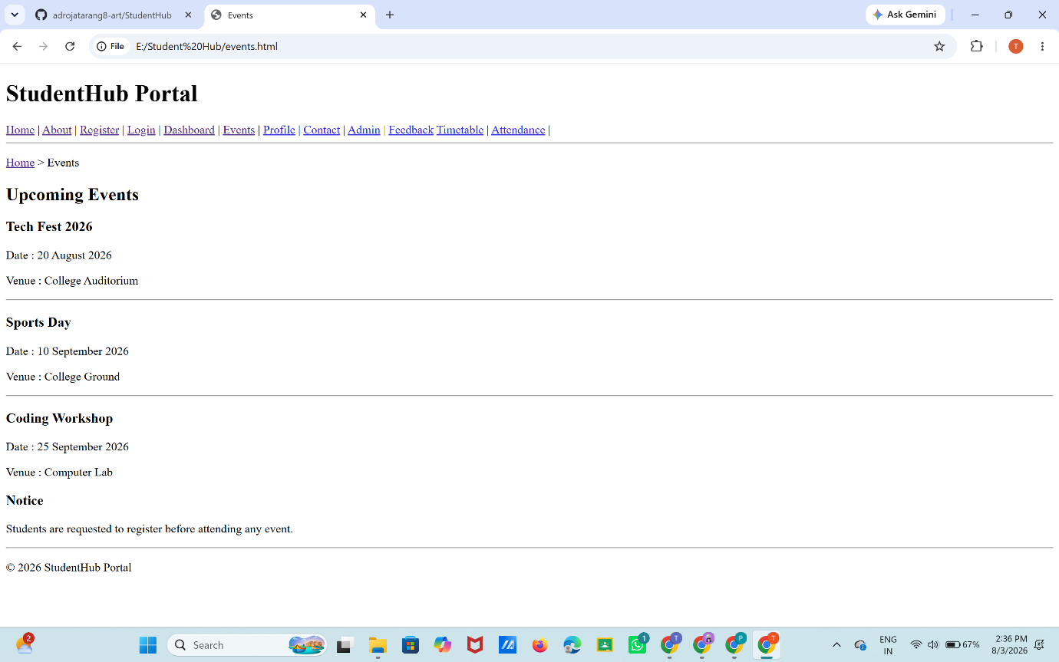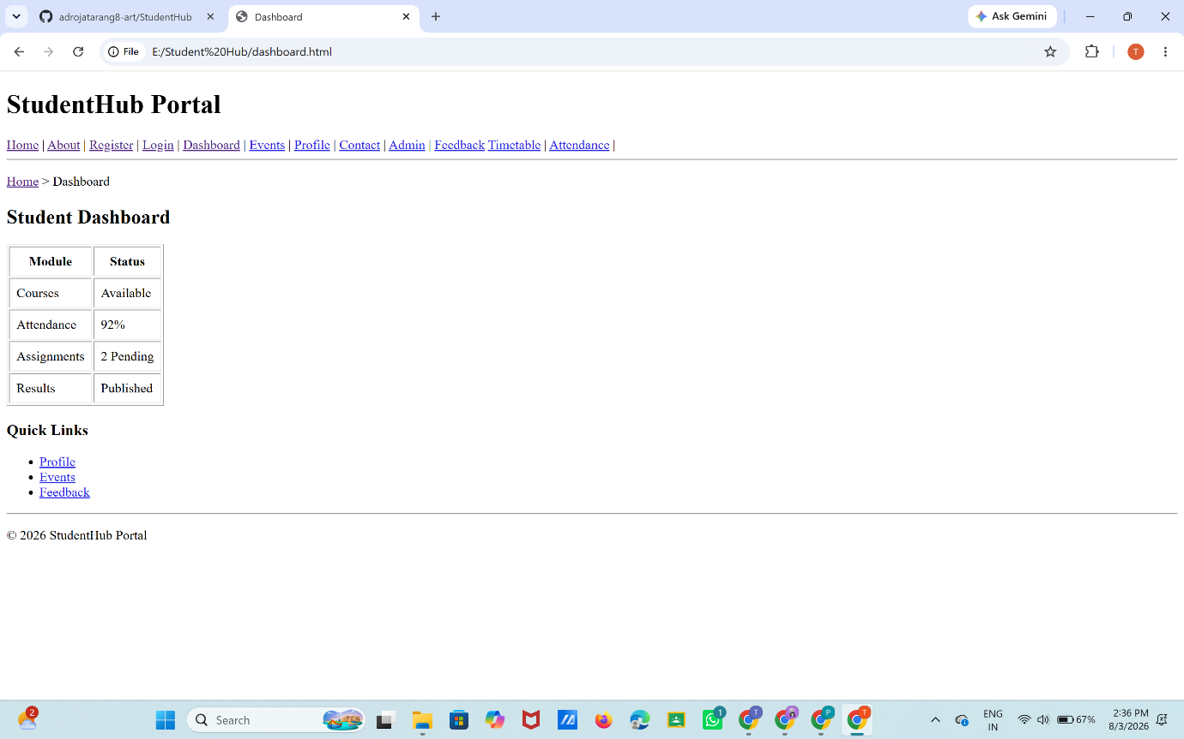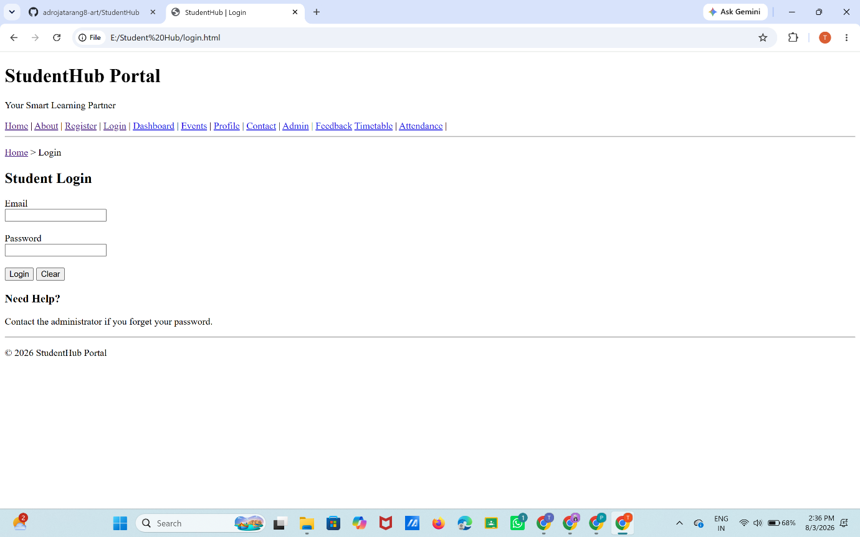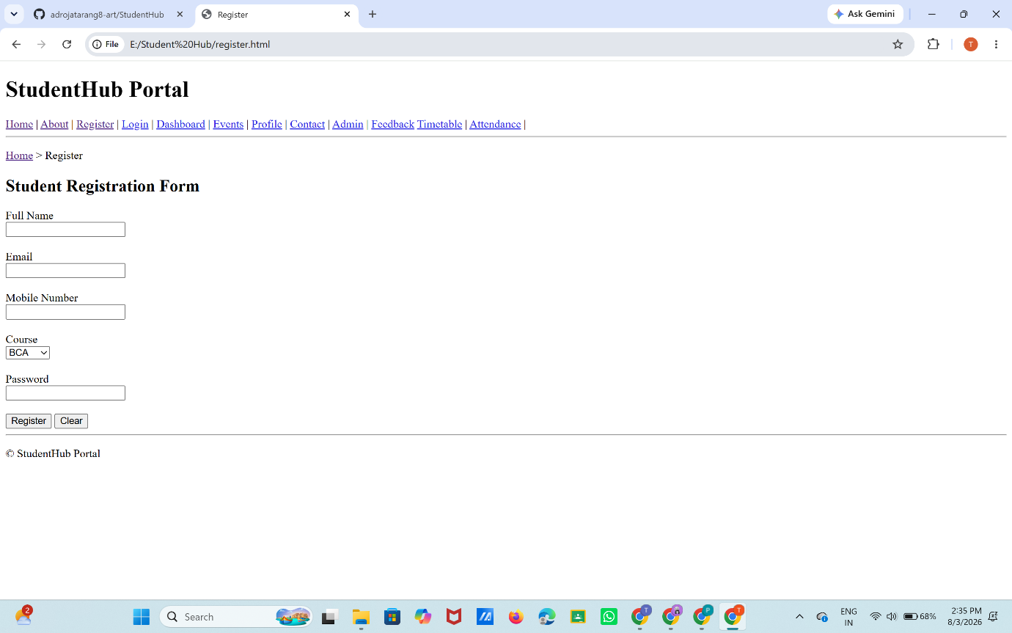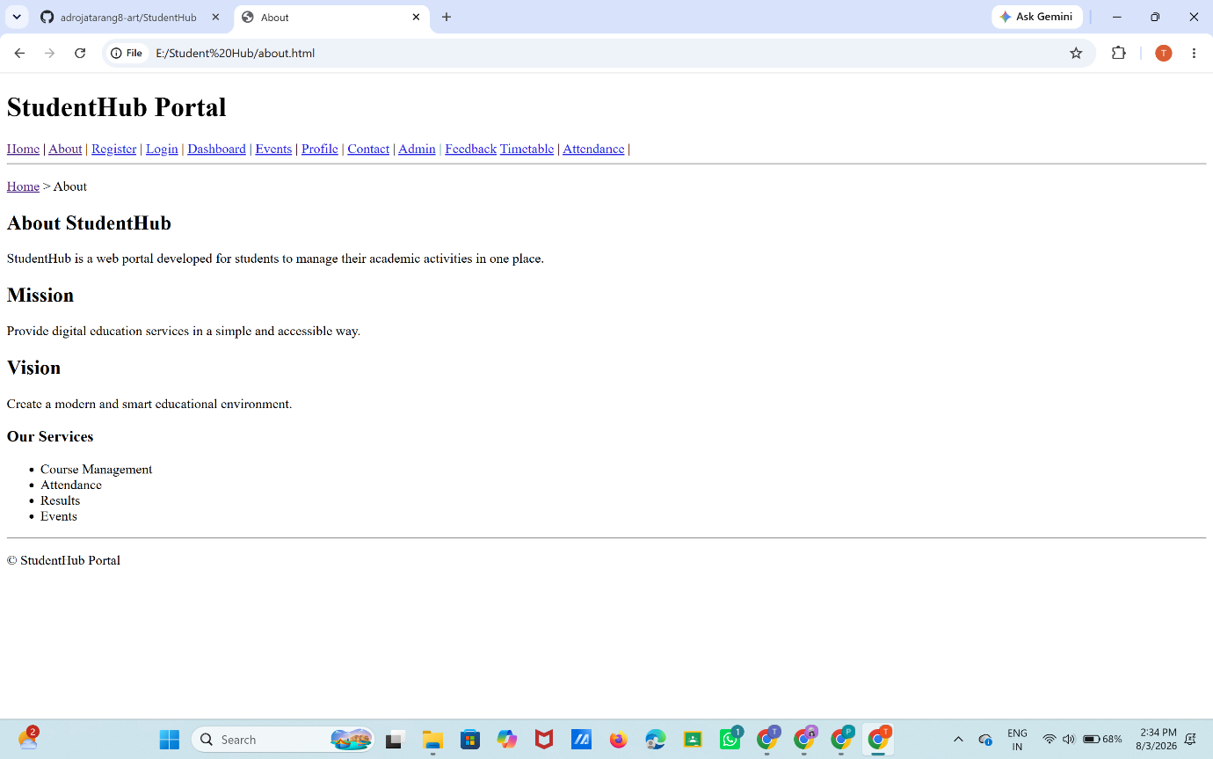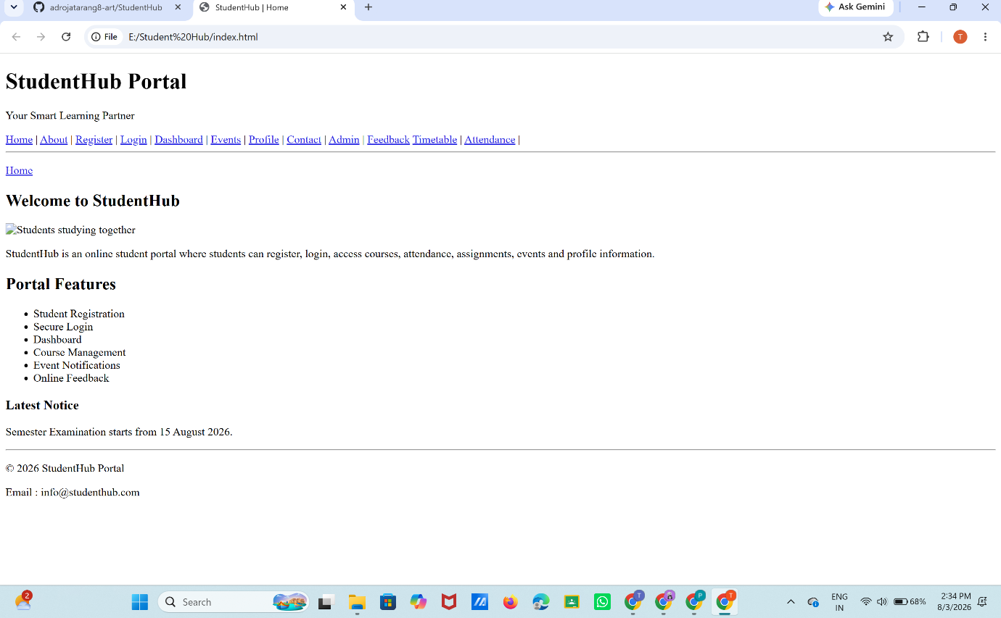

GitHub Repository Link:
https://github.com/adrojatarang8-art/StudentHub.git

Challenges Faced:
GITHUB REPO. CREATION , FOLDER CREATION ,FILE CREATION.
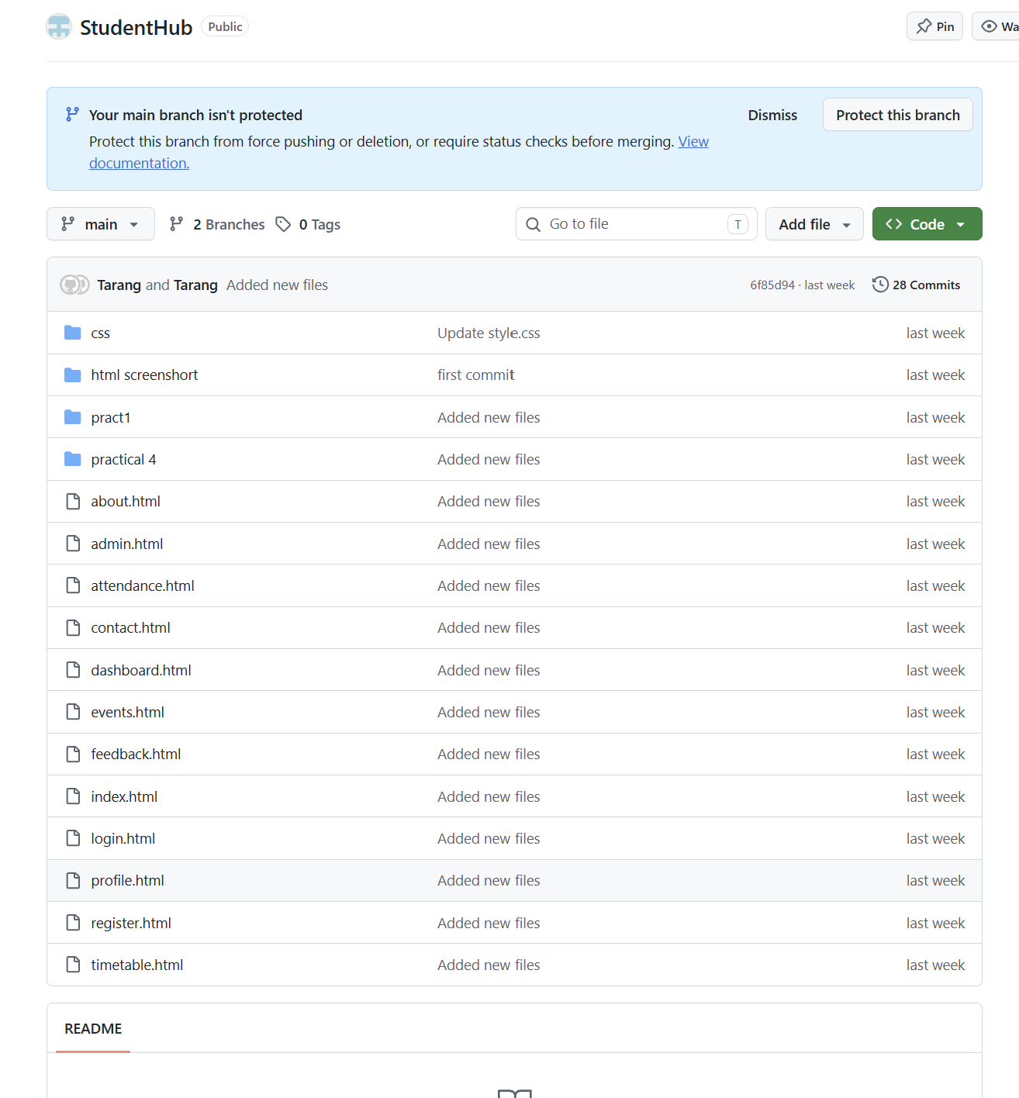
VSCODE FOLDER,FILE CREATION.
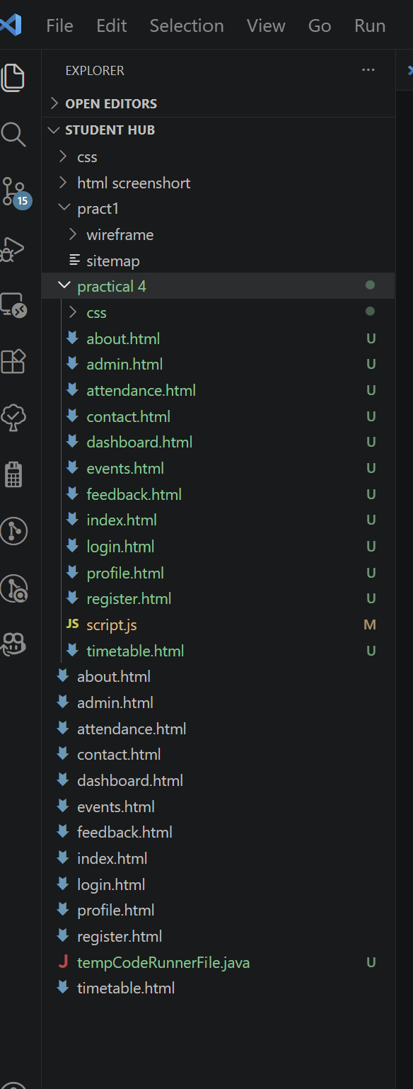

Learning Outcomes:

I LEARNED WEBSITE CREATION, SITEMAP, WIREFRAME, GITHUB, REQUIREMENT ANALYSIS, HTML, FILE MANAGEMENT

Faculty Remarks: (Keep this blank for faculty)

